



Uniform Policy

Date Agreed: | November 2025
Review Date: | November 2026
Type of Policy: | School Policy

Revision  Number | Date Issued | Prepared by | Approved | Personalised by school | Comments
1 | November 2023 | LCS | 30.11.23 | 30.11.23 | School Policy
2 | November 2024 | LM | 18.11.24 | 11.11.24 | Small amendments but main body remains consistent
3 | November 2025 | LM | 12.11.25 tbc | 14.10.25 | Key Updates aligning to Children’s Wellbeing and Schools Bill:  - Branded item limit clarified in Section 3.  - PE kit comfort and inclusivity added to Section 4.1.  - Hair and appearance language softened to allow reasonable adaptations.  - Extracurricular uniform flexibility added to Section 5.1.

Type of Policy | Tick
DCAT Statutory Policy
DCAT Non-statutory Policy
DCAT Model Optional Policy
School Policy
Local Authority Policy

Contents
1. Aims 3
2. Our school’s legal duties under the Equality Act 2010 3
3. Limiting the cost of school uniform 3
4. Expectations for school uniform 4
5. Expectations for our school community 5
6. Monitoring arrangements 6
7. Links to other policies 6

1. Aims
This policy aims to:
- Set out our approach to requiring a uniform that is of reasonable cost and offers the best value for money for parents and carers
- Explain how we will avoid discrimination in line with our legal duties under the Equality Act 2010
- Comply with the Children’s Wellbeing and Schools Bill.
- Clarify our expectations for school uniform

Little Common School believes that our uniform policy serves several important aims that contribute to the overall ethos and functioning of the school:
- Promote equality and inclusivity
- Enhance school identity and pride
- Improve focus on learning
- Encourage discipline and good behaviour
- Simplify morning routines
- Enhance safety and security
- Support a positive school culture
- Foster a sense of belonging and community

2. Our school’s legal duties under the Equality Act 2010
The Equality Act 2010 prohibits discrimination against an individual based on the protected characteristics, which include age, sex, disability, race, religion or belief, pregnancy and maternity, and gender reassignment.

To avoid discrimination, our school will:

- Avoid listing uniform items based on sex, to give all pupils the opportunity to wear the uniform they feel most comfortable in or that most reflects their self-identified gender
- Make sure that our uniform costs the same for all pupils
- Allow all pupils to have long hair (though we reserve the right to ask for this to be tied back)
- Allow all pupils to style their hair in a way that is appropriate for school and makes them feel most comfortable
- Allow pupils to request changes to swimwear for religious reasons or if they are experiencing discomfort related to their sex, gender or gender reassignment
- Allow pupils to wear headscarves and/or other religious garments
- Allow pupils with sensory or physical needs to make reasonable adaptations to their uniform. Requests for adaptations should be made by contacting the school office, and will be considered on a case-by-case basis
- Allow for reasonable adaptations to our policy on the grounds of equality. Parents or pupils should contact the school office to discuss any requests, which will be considered on a case-by-case basis

3. Limiting the cost of school uniform
Our school has a duty to make sure that the uniform we require is affordable, in line with statutory guidance from the Department for Education on the cost of school uniform.
We understand that items with distinctive characteristics (such as branded items, or items that have to have a school logo or a unique fabric/colour/design) cannot be purchased from a wide range of retailers and that requiring many such items limits parents’ ability to ‘shop around’ for a low price.
In line with the Children’s Wellbeing and Schools Bill, we limit branded items to no more than three, ensuring they are low-cost and long-wearing. No branded items are required for extracurricular activities.

We will make sure our uniform:
- Is available at a reasonable cost
- Provides the best value for money for parents/carers
We will do this by:
- Carefully considering whether any items with distinctive characteristics are necessary
- Limiting any items with distinctive characteristics where possible
- Limiting items with distinctive characteristics to low-cost and/or long-lasting items, such as ties and the choice of a logo jumper
- Considering cheaper alternatives to school-branded items, such as plain knit dark green V neck jumper
- Avoiding specific requirements for items pupils could wear on non-school days, such as coats and bags
- Keeping the number of optional branded items to a minimum, so that the school’s uniform can act as a social leveller
- Avoiding different uniform requirements for different year groups
- Avoiding different uniform requirements for extra-curricular activities
- Considering alternative methods for signalling differences in groups for interschool competitions, such as different colour bibs
- Making sure that arrangements are in place for parents to acquire second-hand free uniform items
- Avoiding frequent changes to uniform specifications and minimising the financial impact on parents of any changes
- Consulting with parents and pupils on any proposed significant changes to the uniform policy and carefully considering any complaints about the policy

4. Expectations for school uniform
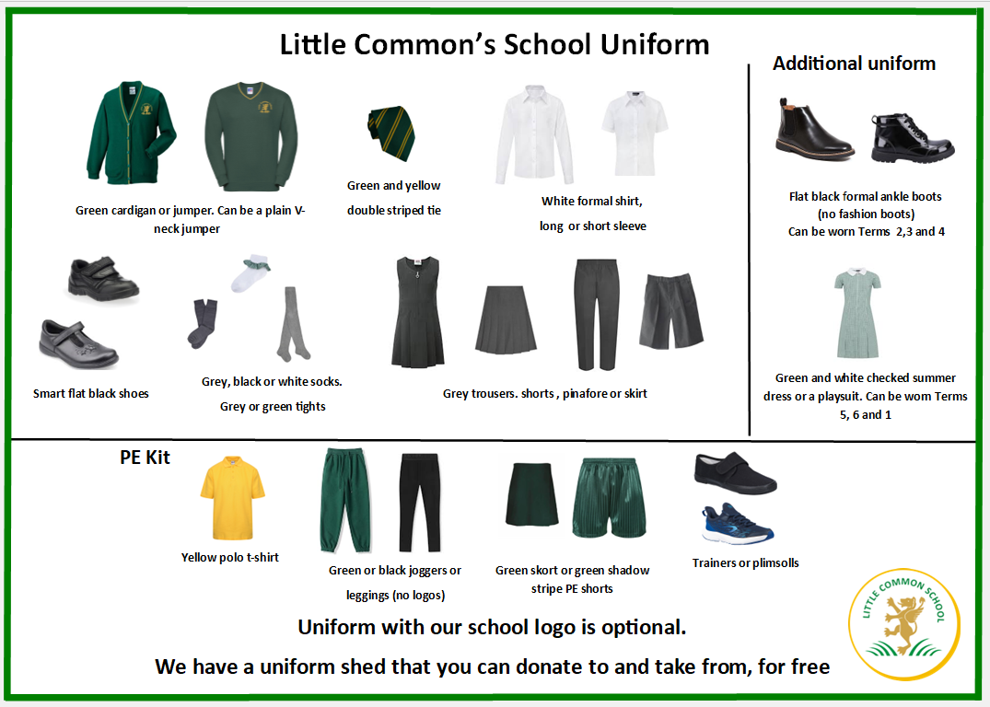
4.1 Our school’s uniform

Only small stud earrings and jewellery of religious significance may be worn. Earrings must be removed or covered for PE.

Nail varnish, unnatural hair colours and temporary tattoos are NOT allowed. The wearing of make-up, artificial nails or false eyelashes is strictly prohibited.

Long hair including fringes must be tied back to allow full vision, with discreet bands and grips in either dark green or black.

Hair styles should be smart in appearance. Reasonable adaptations will be permitted to support identity, wellbeing, or cultural expression.

On PE days, pupils wear their PE kit all day to reduce anxiety around changing.

Uniform Expectations
- Children may wear long-sleeved or short-sleeved formal shirts/blouses all year round.
- School ties must be worn with all shirts/blouses.
- Children may wear school trousers or tailored school shorts all year round.
- Sensible black school shoes must be worn throughout the year.
- Polo shirts are not part of our school uniform and must not be worn.
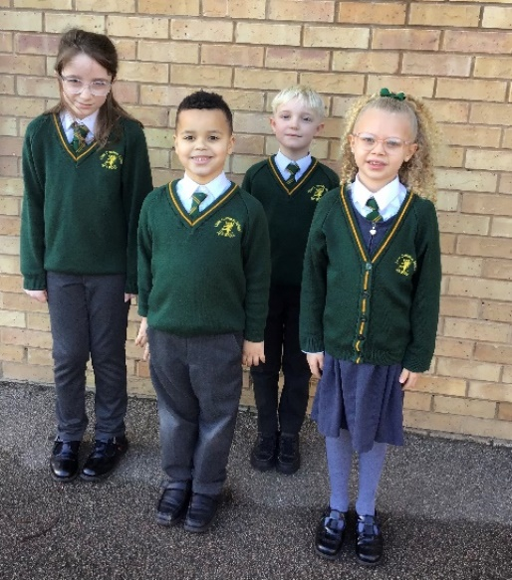
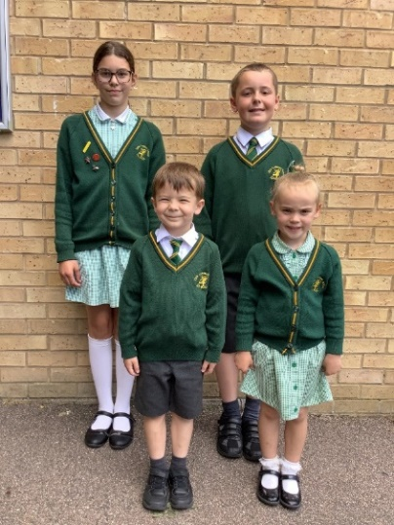

Seasonal Items
The uniform includes summer and winter options to reflect seasonal temperatures as follows:
- Formal style ankle boots (no fashion boots) may be worn during the winter months only (Terms 2, 3 and 4). If boots become wet or muddy, a change of footwear may be required for indoor wear.
- Dark green checked summer dress or playsuit may be worn during the summer months only (Terms 5, 6, 1).

PE kit
Yellow polo shirt
Dark green shadow stripe sports shorts or dark green skort
White sport socks
Black plimsolls or trainers
Optional for outdoor PE only: dark green/black tracksuit bottoms/leggings – must be plain with no logos or patterns


4.2 Where to purchase it
The school tie and logo jumper can be purchased through Superstich86 either by visiting their store in Hastings or ordering online. The store also sells all other garments of the uniform, however they are also available from many other local stores and supermarkets.
Tel: 01424 852225
Email: schooluniform@superstitch86.co.uk
Address: Super Stitch 86, 7 Castleham Road, St Leonards on Sea, East Sussex TN38 9NR

The school also has a recycle unit open daily at the school. Parents can drop off outgrown uniform and collect replacement uniform free of charge.

5. Expectations for our school community
5.1 Pupils
Pupils are expected to wear the correct uniform at all times; this includes the PE uniform on PE days (other than specified non-school uniform days) while:
- On the school premises
- Travelling to and from school
- At out-of-school events or on trips that are organised by the school, or where they are representing the school.
- Pupils are not required to wear branded uniform for extracurricular activities, including clubs, trips, and performances.
Pupils are also expected to contact the Headteacher through the school office if they want to request an amendment to the uniform policy in relation to their protected characteristics.
5.2 Parents and carers
Parents and carers are expected to make sure their child has the correct uniform and PE kit, and that every item is:
- Clean
- Clearly labelled with the child’s name
- In good condition
Parents are also expected to contact the Headteacher through the school office if they want to request an amendment to the uniform policy in relation to:
- Their child’s protected characteristics
- The cost of the uniform
Parents are expected to lodge any complaints or objections relating to the school uniform in a timely and reasonable manner.

Disputes about the cost of the school uniform will be:
- Resolved locally
- Dealt with in accordance with our school’s complaints policy
The school will work closely with parents to arrive at a mutually acceptable outcome.
5.3 Staff
Staff will closely monitor pupils to make sure they are in correct uniform. They will give any pupils and families breaching the uniform policy the opportunity to comply, but will follow up with the headteacher if the situation doesn’t improve.
Ongoing breaches of our uniform policy will be dealt with by the Headteacher.
In cases where it is suspected that financial hardship has resulted in a pupil not complying with this uniform policy, staff will take a mindful and considerate approach to resolving the situation.
5.4 Governors
The governing board will review this policy and make sure that it:
- Is appropriate for our school’s context
- Is implemented fairly across the school
- Takes into account the views of parents and pupils
- Offers a uniform that is appropriate, practical and safe for all pupils
The board will also make sure that the school’s uniform supplier arrangements give the highest priority to cost and value for money.

6. Monitoring arrangements
This policy will be reviewed annually by the Headteacher. At every review, it will be approved by the full governing board.

7. Links to other policies
This policy is linked to our:
- Behaviour policy
- Equality information and objectives statement
- Complaints policy

